**OS/2 COMMANDS**

|  |  |
| --- | --- |
| NAME | RAVELLA ABHINAV |
| ROLL No. | CB.EN.U4CSE19453 |

**NAVIGATING TO THE COMMAND SHELL**

**Steps :**

1. Desktop
2. OS/2 System
3. Command Prompt
4. OS/2 Window

SCREEN SNIPPETS OF PATH :

(step-wise as follows)

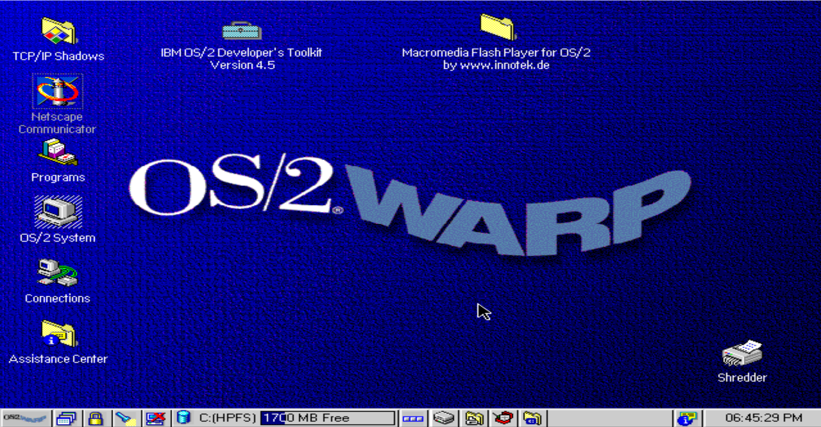

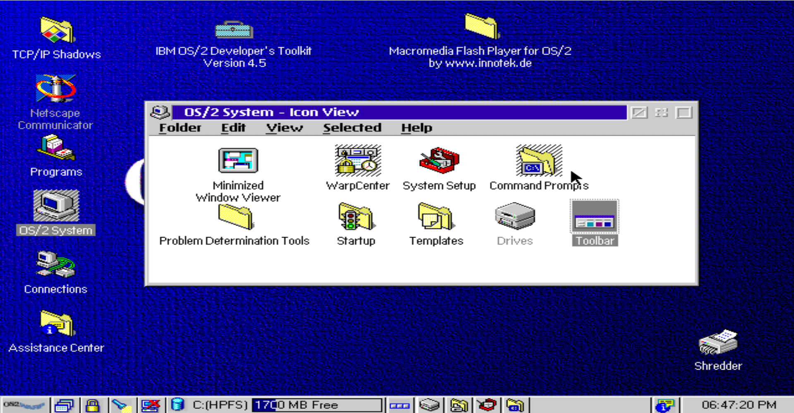

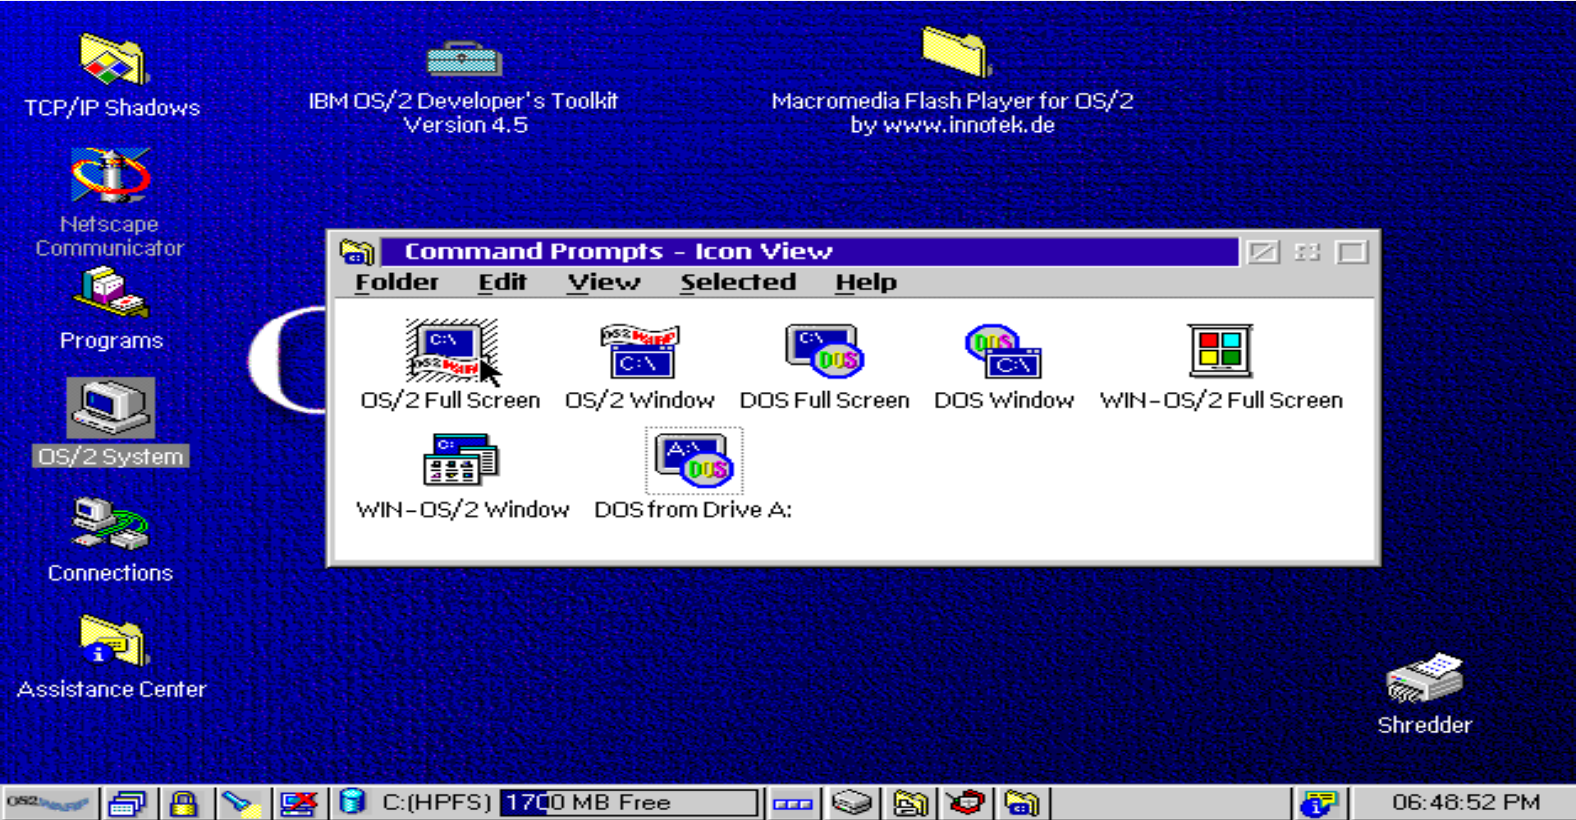

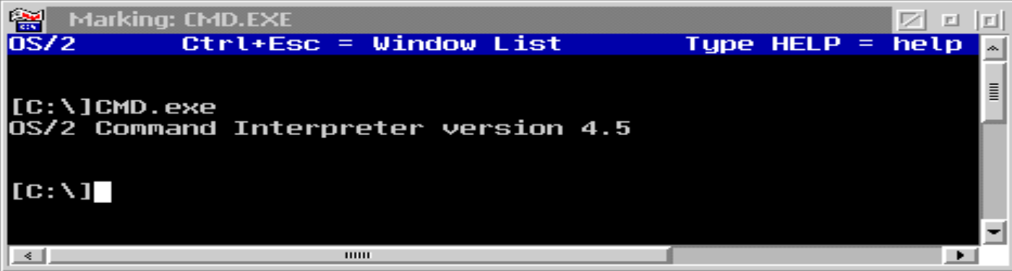

**IMPLEMENTATION OF BASIC COMMANDS**

1. **echo :**

a command that outputs the strings it is being passed as arguments

1. **mkdir :**

Makes new subdirectories within the root directory. It creates a multilevel directory structure, which is helpful in keeping related program or data files together.

1. **cd :**

Changes the current directory

1. **chkdsk :**

Analyzes directories and files, determines the file system type, and produces a disk status report. CHKDSK also displays the volume label and the volume serial number of the disk.

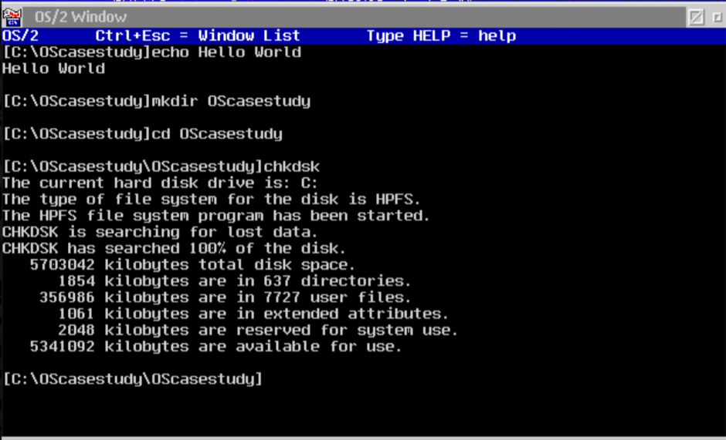

1. **dir :** Lists the files and subdirectories in a directory.

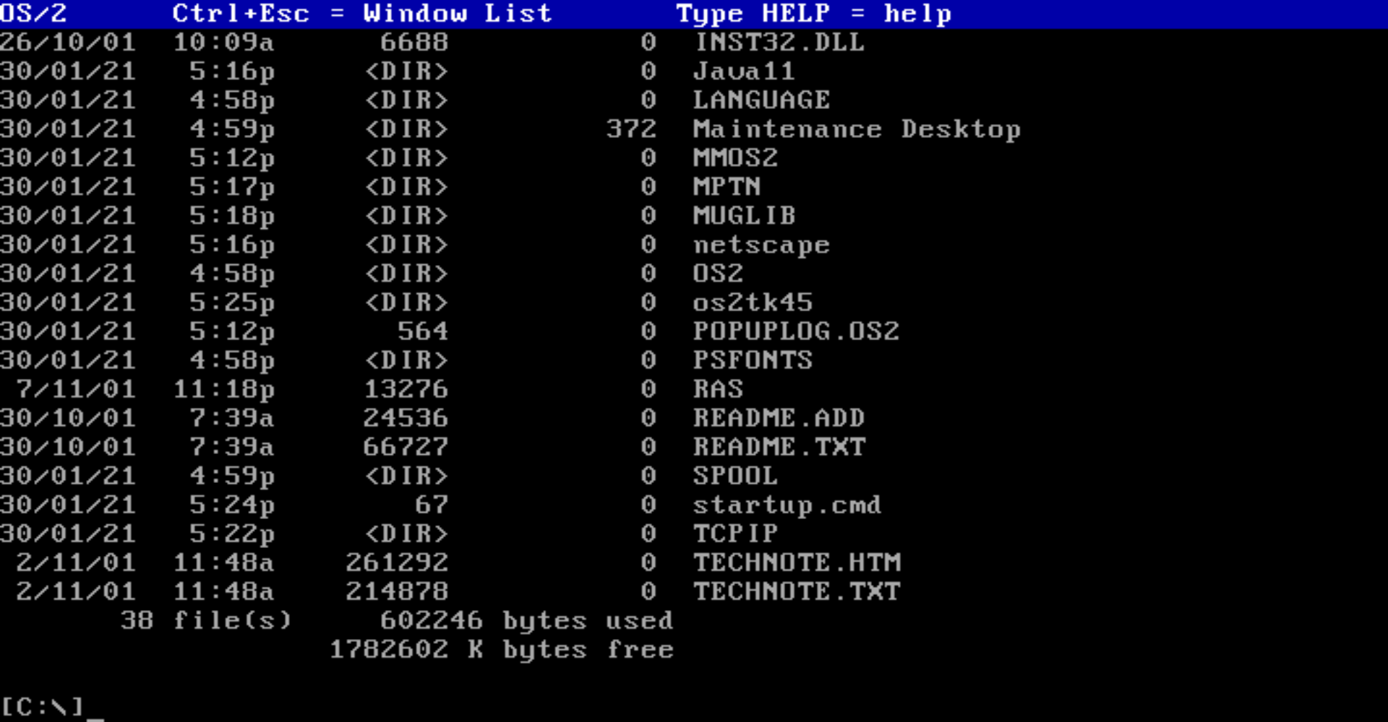

**----------------------------------THANKYOU -------------------------------**